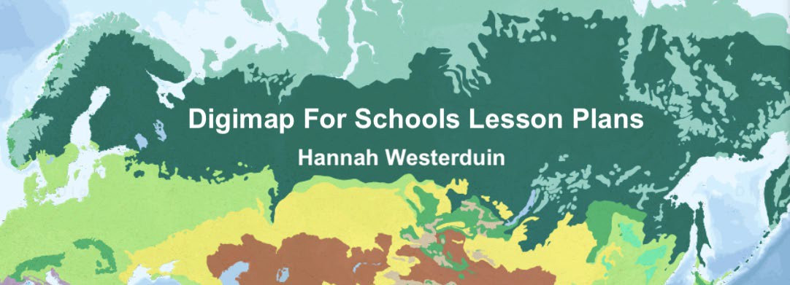



**LESSON PLAN 1**

# Tectonics, Volcanoes and Mountain Ranges

**Teacher Guide**

**Geography Teaching Resource** **Secondary Ages 11-14 KS3 and Level 3/4**

**Tectonics, Volcanoes and Mountain Ranges**

**Teacher Guide**

The aim of this resource is to explore the World Physical Geography overlays of Mountain ranges, volcanoes, tectonic plates and tectonic plate boundaries. There is a corresponding worksheet for distribution to students that supplements this lesson plan. Note: This resource is estimated to take 2+ lessons of 45 minutes to complete.

## Table of Contents

Tectonics, Volcanoes and Mountain Ranges 2

Table of Contents 2

Learning Objectives 2

Curriculum for Excellence Links 3

1. Tectonic Plates 4

Activity 5

1. Volcanoes 7

Case study: Iceland’s Eyjafjallajokull volcano 7

Activity 8

Volcanoes and people 9

1. Mountain Ranges 11

Activity 11

Settlements and physical features 12

BBC Bitesize quizzes 14

Bibliography 15

Copyright 16

### Learning Objectives:

By the end of this worksheet students should be able to:

* Use overlays to locate tectonic plates across the Globe.
* Describe the different types of tectonic plate boundaries.
* Describe how tectonic plate movement has formed landscapes across the world.
* Understand how tectonic plate boundaries influence the presence of volcanoes.
* Describe the different types of volcano.
* Understand the extent of volcanic eruptions.
* Describe the potential consequences for people living nearby.
* Understand how the movement of tectonic plates can cause mountain forming events, such as the Himalayas.
* Understand how physical features dictate where people choose to live.
* Use Digimap for Schools to create a map.

|  |  |  |
| --- | --- | --- |
| **Level** | **Context** | **Location** |
| Secondary KS3  CfE Level 3  and Level 4 | Tectonic plates, volcanoes and mountain ranges | Global with Case studies:   * Indian and Burma tectonic plates * Eyjafjallajokull volcano Iceland * Himalayas |

### Curriculum for Excellence Links

|  |  |  |
| --- | --- | --- |
| **Es and Os** | **Experiences and Outcomes for planning learning, teaching and assessment** | * **Benchmarks to support practitioners’ professional judgement of achievement of a level** |
| SOC 3-07a | Having investigated processes which form and shape landscapes. I can explain their impact on selected landscapes in Scotland, Europe and beyond. | * Identifies the processes which form landscapes across the world. * Provides a simple explanation of at least three processes involved in the development of any chosen landscape, for example, coasts, volcanic, rivers or glaciated. |
| SOC 3-08a | I can identify the possible consequences of an environmental issue and make informed suggestions about ways to manage the impact. | * Provides a simple explanation of at least three consequences of an environmental issue, and for each suggest how they could be managed. |
| SOC 4-07a | I can explain how the interaction of physical systems shaped and continue to shape the Earth’s surface by assessing their impact on contrasting landscape types. | * Explains in some detail how at least two landscape types from across the globe are formed. |

## Tectonic Plates

The Earth’s crust is divided up by large slabs known as tectonic plates. Movement in the Earth’s core causes these plates to move, often a few centimetres a year which eventually leads to places on the Earth’s surface moving thousands of kilometres apart. This process is known as continental drift **(**BBC Bitesize, 2022a).

At the boundaries between tectonic plates, plates interact by moving apart, towards or under each other, this causes the Earth’s crust to be unstable. Tectonic plate interactions can cause earthquakes, volcanic eruptions and the creation of mountain ranges as the earth’s surface is distorted (BBC Bitesize, 2022a).

There are 4 types of plate boundary: convergent, divergent, transform and subduction, which are defined by the motion of the plates in relation to each other (Westerduin, 2021a). Sections of Earth’s crust can come together and collide (a “convergent” plate boundary), spread apart (a “divergent” plate boundary) as seen in the East African Rift, or slide past one another (a “transform” plate boundary) such as the San Andreas Fault (National Geographic Society, 2021b).

A single tectonic plate can have multiple types of plate boundaries with the other plates that surround it. For instance, the Pacific Plate, one of Earth’s largest tectonic plates, includes convergent, divergent, and transform plate boundaries. A convergent plate boundary forms mountain ranges like the Himalayas as the Earth’s crust is crumpled and pushed upward. In some cases, however, a convergent plate boundary can result in one tectonic plate diving underneath another (National Geographic Society, 2021b).

This process, called “subduction,” involves an older, denser tectonic plate being forced underneath a younger, less-dense tectonic plate. When subduction occurs, a chain of volcanoes often develops near the convergent plate boundary, because molten rock from the Earth’s core, magma, can travel upward at these intersections between plates such as along the West coast of the US (National Geographic Society, 2021b).

Learn about the different types of tectonic plate boundaries here:

BBC Bitesize (2022e) <https://www.bbc.co.uk/bitesize/guides/zyhv4wx/revision/2>

Note: The BBC bitesize page has different names to the Digimap for Schools plate boundaries, to avoid confusion you may wish to use the definitions above that correspond with the Digimap for Schools overlays.

### Activity

#### Open Digimap for Schools

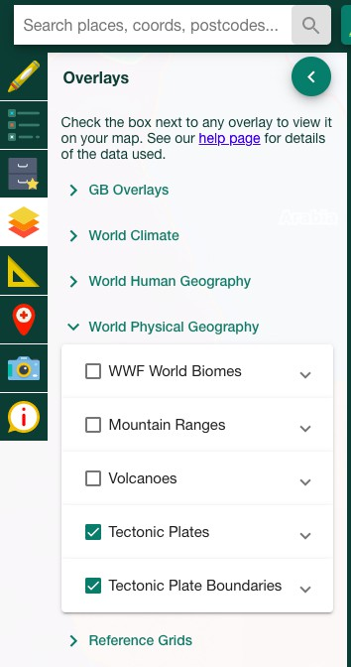First, select the Tectonic plate and the Tectonic plate boundaries overlays.

*Alt Text: Image showing where to find tectonic plate and tectonic plate boundary overlays in the Digimap for Schools overlays panel.*

* 1. How many tectonic plates make up the Earth’s crust? A= 4) 52

Using the tectonic plate overlays, find the Burma tectonic plate (Hint it lies over the Andaman Islands between India and Thailand).

* 1. What type of plate boundary lies between the Indian and Burma tectonic plate? A = 3) Subduction

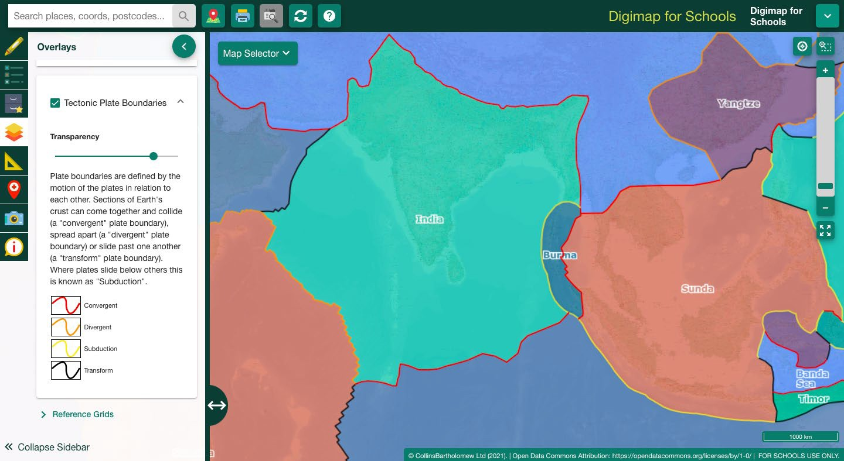

*Alt Text: Map showing the tectonic plates and tectonic plate boundaries overlay over India and Asia in the Digimap for Schools interface.*

* 1. What type of plate boundary lies between the Burma and Sunda plate?

A= 1) Convergent

* + 1. Which way are the Burma and Sunda plates moving relative to each other?

A= 2) Moving towards each other

* + 1. What might happen at this plate boundary as a result of the tectonic plate movements?

Choose 3:

* + - 1. The plates are forced upwards to form fold mountains.
      2. Friction between the plates triggers earthquakes
      3. New land is created in the gap between the plates
      4. Magma might rise up through cracks and erupt onto the surface.

## Volcanoes

Select the volcanoes overlay and locate Iceland on the map. Volcanoes are created through the upwelling of magma often where there are faults in the Earth’s crust. Due to a tectonic plate boundary running through the middle, Iceland is a hotspot for volcanic activity.

* 1. What are the two tectonic plates and which way are they moving? A= North America and the Eurasia tectonic plates, moving apart.

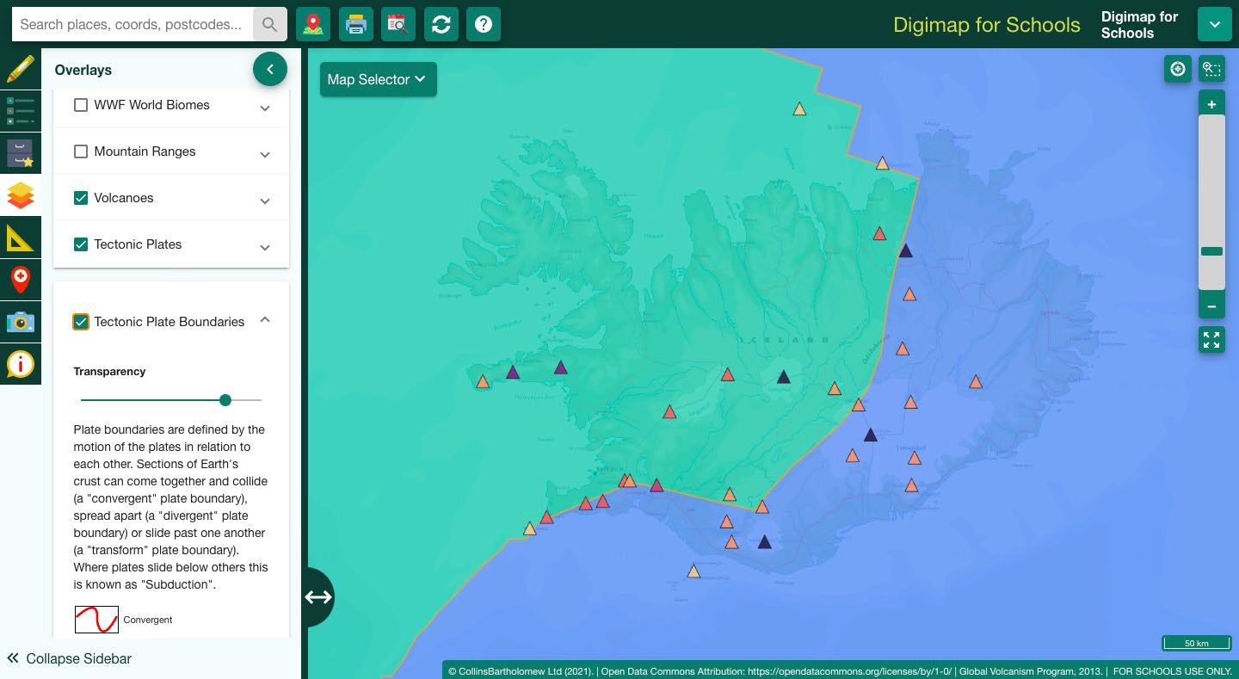

*Alt Text: Map showing Tectonic plates and Volcanoes over Iceland. A tectonic plate boundary runs through the middle and there are lots of volcanoes.*

Iceland is also home to a range of different volcano types. Learn about the different volcano types here: <https://digimapforschools.edina.ac.uk/files/overlay_guides/volcanoes_user_guide.pdf>

### Case study: Iceland’s Eyjafjallajokull volcano

Eyjafjallajokull erupted in April 2010. Learn about Eyjafjallajokull here: <https://www.bbc.co.uk/bitesize/guides/zvnbkqt/revision/4>

Latest Eyjafjallajokull activity report from the Global Volcanism Program: <https://volcano.si.edu/volcano.cfm?vn=372020>

* 1. Write down 3 things that you learnt about the eruption. 1.

2.

### Activity

Find Iceland’s Eyjafjallajokull volcano. (hint use the Get Feature Information tool to see the volcano names)

Get Feature Info. tool 

*Alt Text: Get Feature Information tool. A magnifying glass over an information icon*

1. Once you found the volcano, use the ‘text box’ tool to label it, then click on the volcano after selecting the ‘Gridref’ tool.



* 1. What is the grid reference?
     1. A= 63.6225, -19.6323

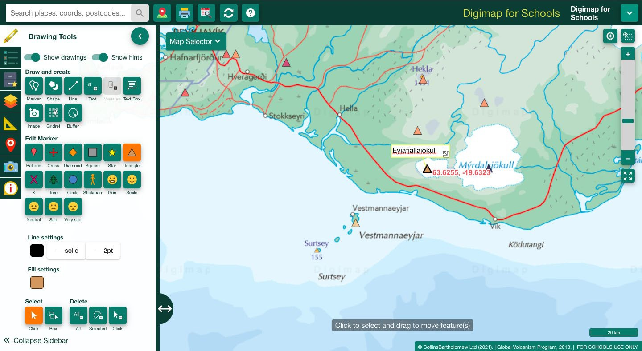

*Alt Text: Map showing the Eyjafjallajokull volcano in Iceland and grid reference displayed next to it. The drawing tools panel and can be seen on the left hand side.*

1. Ash and rock particles from the Eyjafjallajokull eruption reached a distance of 70km from the volcano. Use the buffer tool to investigate the area that would be affected by volcanic ash. (hint select the point buffer tool, input the distance and then click on Eyjafjallajokull)
   1. What area does this cover? (hint use the measure tool and click on the buffer circle)

A= 15324.4km2

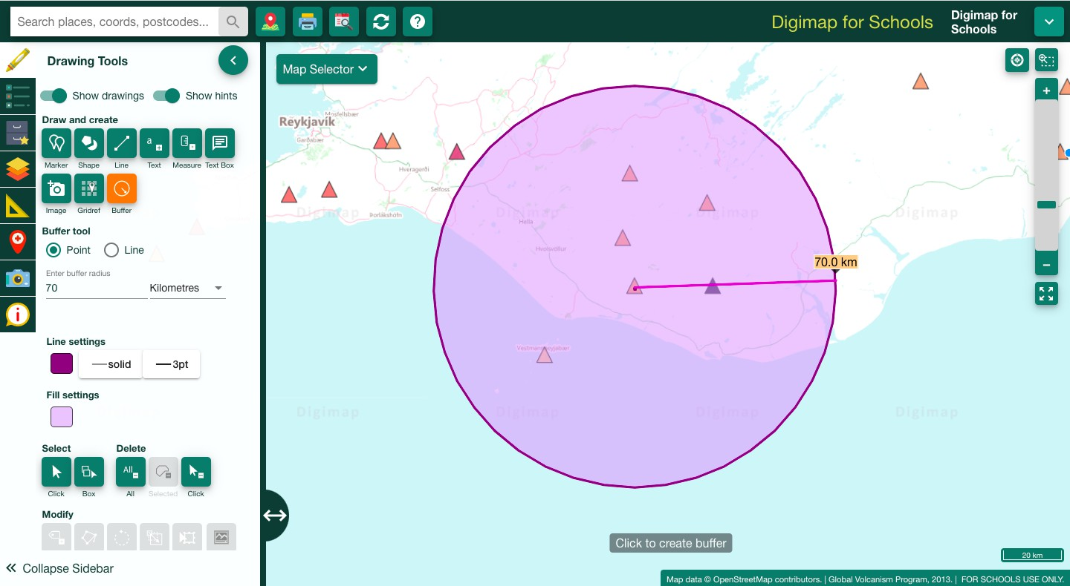

*Alt Text: Map showing a buffer surrounding the Eyjafjallajokull volcano.*

### Volcanoes and people

The number of people living in an area can be defined by population density. You can calculate this by dividing the number of people in an area by the size of the area.

Population density = the number of people per km2 / the size of the area in km2 <https://www.bbc.co.uk/bitesize/guides/zkg82hv/revision/2> (BBC Bitesize, 2022c)

1. Select the Population density overlay under the ‘World human geography’ section. Where are areas with a higher population density that may be affected by another eruption?

A = Reykjavík

1. Use the Distance tool under the measurement tab to calculate the distance between Eyjafjallajokull and Iceland’s capital city.

A= 15330.4km2

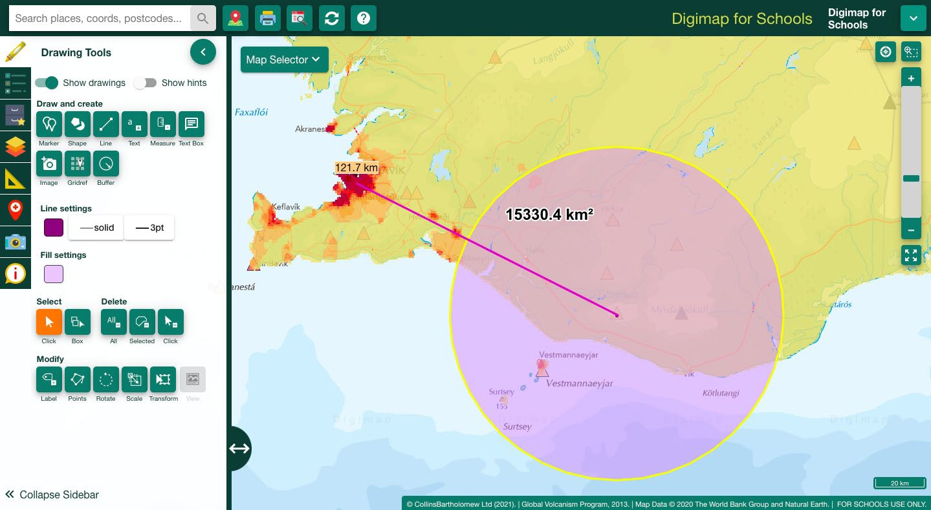

*Alt Text: Map showing a buffer surrounding the Eyjafjallajokull volcano.*

1. Describe what the consequences might be if there was a larger eruption. (hint use https://[www.bbc.co.uk/bitesize/guides/zvnbkqt/revision/3](http://www.bbc.co.uk/bitesize/guides/zvnbkqt/revision/3) to list 3 potential impacts of a big eruption)
2. How might these consequences be managed?
3. Print Tool Select the “generate file for printing” tool to create a map of what you have done.

*Alt Text: Print tool*

## Mountain Ranges

The movement of tectonic plates can cause mountain forming events. Select the Tectonic plate and Mountain Ranges overlays and zoom to the Himalayas (Hint: alter the transparency of the tectonic plate overlay to see the mountain ranges). A convergent plate boundary has caused uplift of the crust between the Indian and Eurasian plates forming the Himalayan Mountain range.

### Activity

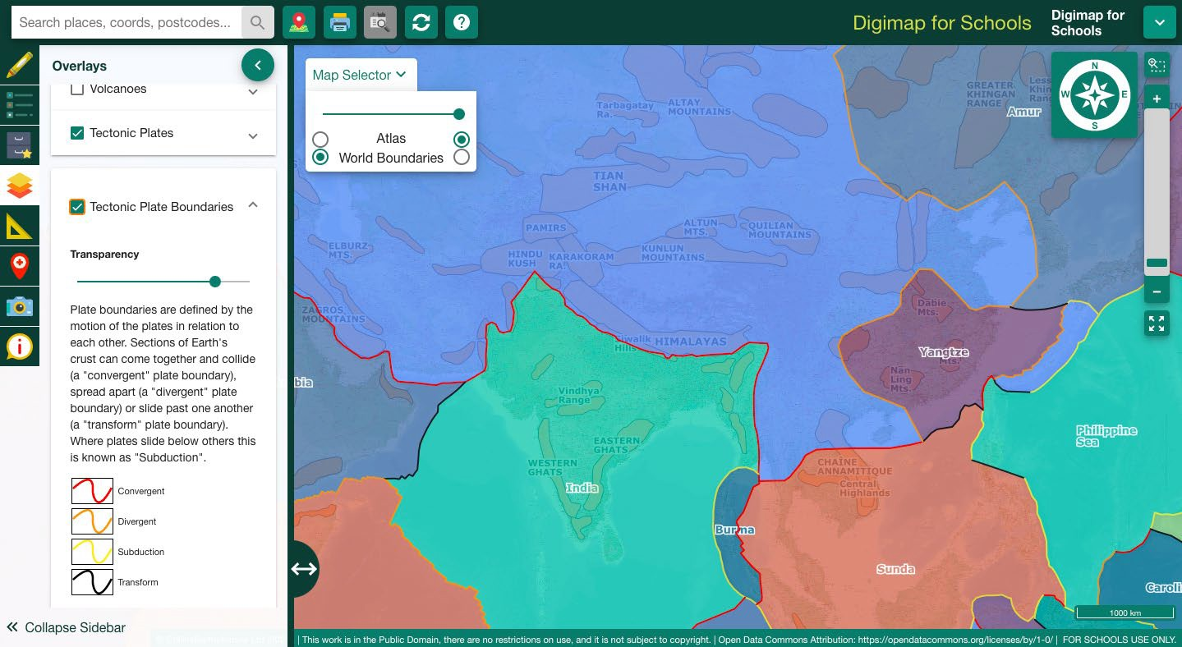

*Alt text: Map showing the tectonic plates, tectonic plate boundaries and mountain ranges overlays over Asia in the Digimap for Schools interface.*

* 1. What is the area of the Himalayas Mountain range? (Hint use the freehand shape tool to trace the feature and then use the ‘measure’ tool to calculate the area)
     1. A= 458851.8km2

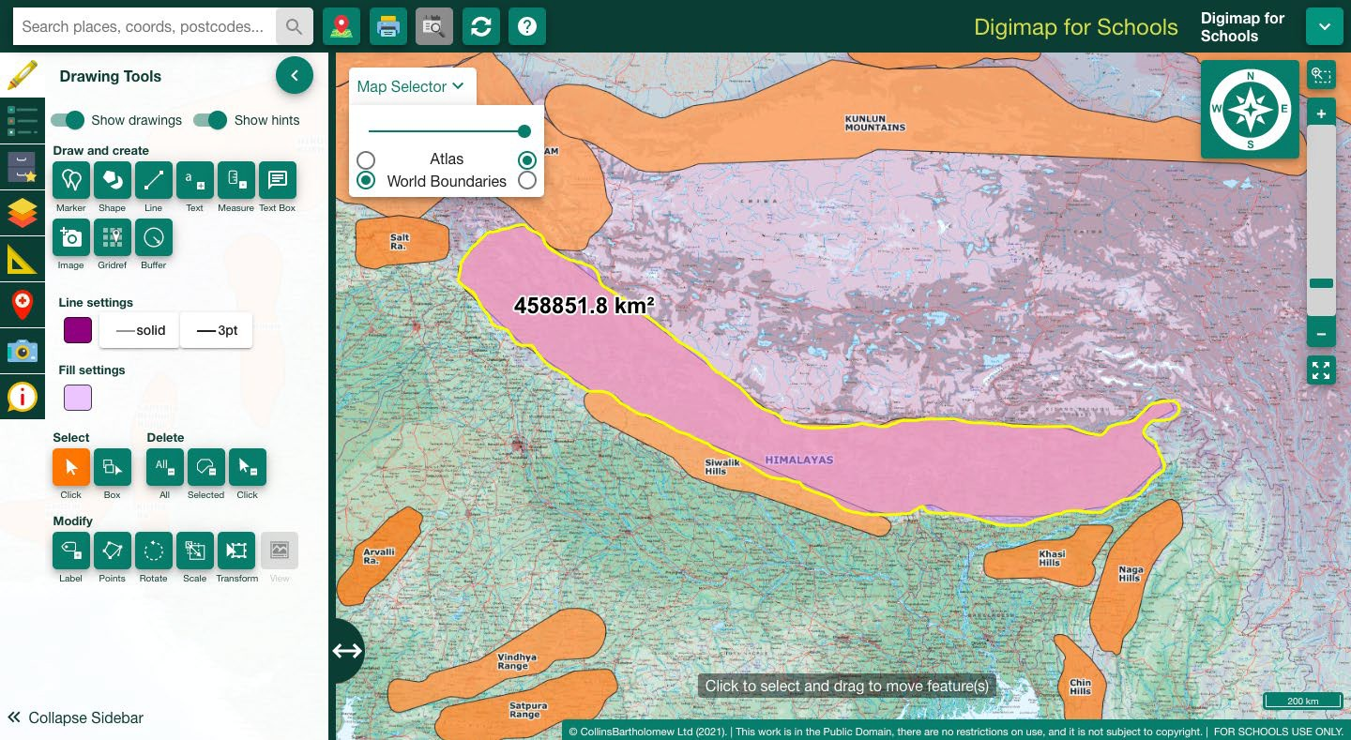

*Alt text: Map showing the area of the Himalayan Mountain Range.*

### Settlements and physical features

Places where people live are called settlements, these can be described through a settlements site, situation and pattern (BBC Bitesize, 2022d).

**Site** - this is the place where the settlement is located, eg on a hill or in a sheltered valley. **Situation** - this describes where the settlement is in relation to other settlements and the features of the surrounding area, eg is the settlement surrounded by forest or is it next to a large city?

Situation can be described using the 3 main types of settlement patterns; dispersed, nuclear and linear.

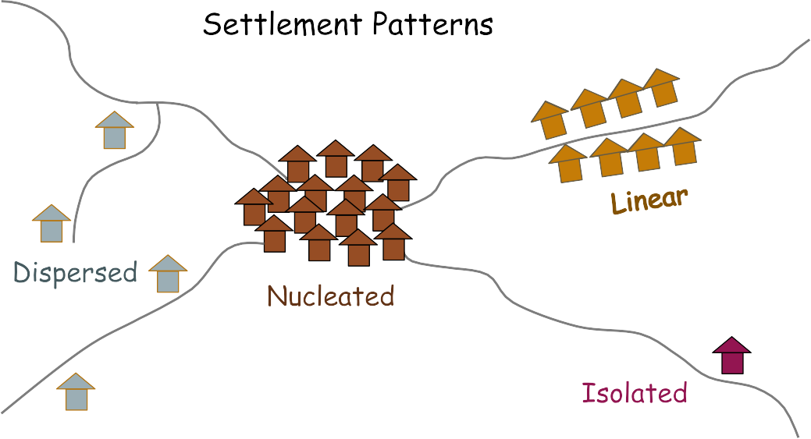

*Alt text: Diagram showing settlement patterns. Dispersed, nucleated, isolated and linear settlements.*

Learn more about these here: <https://www.3dgeography.co.uk/settlement-patterns>

* 1. Select the population density overlay. What are the ways in which physical features like mountain ranges affect settlement patterns?

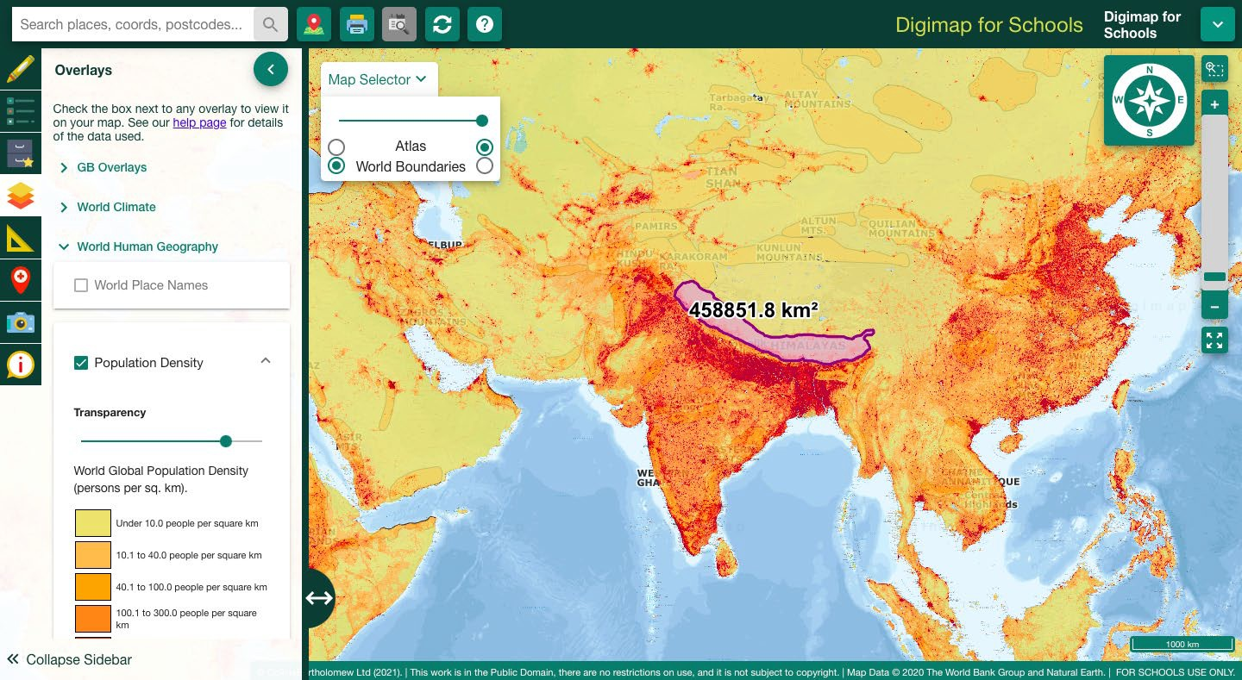

*Alt Text: Map showing the Himalayan Mountain Range and population density overlay.*

Extra activity: Find your nearest Mountain Range. Either the Grampian mountains in Scotland or the Cambrian Mountains in Wales. Measure the area, how does this compare in size to the Himalayas?

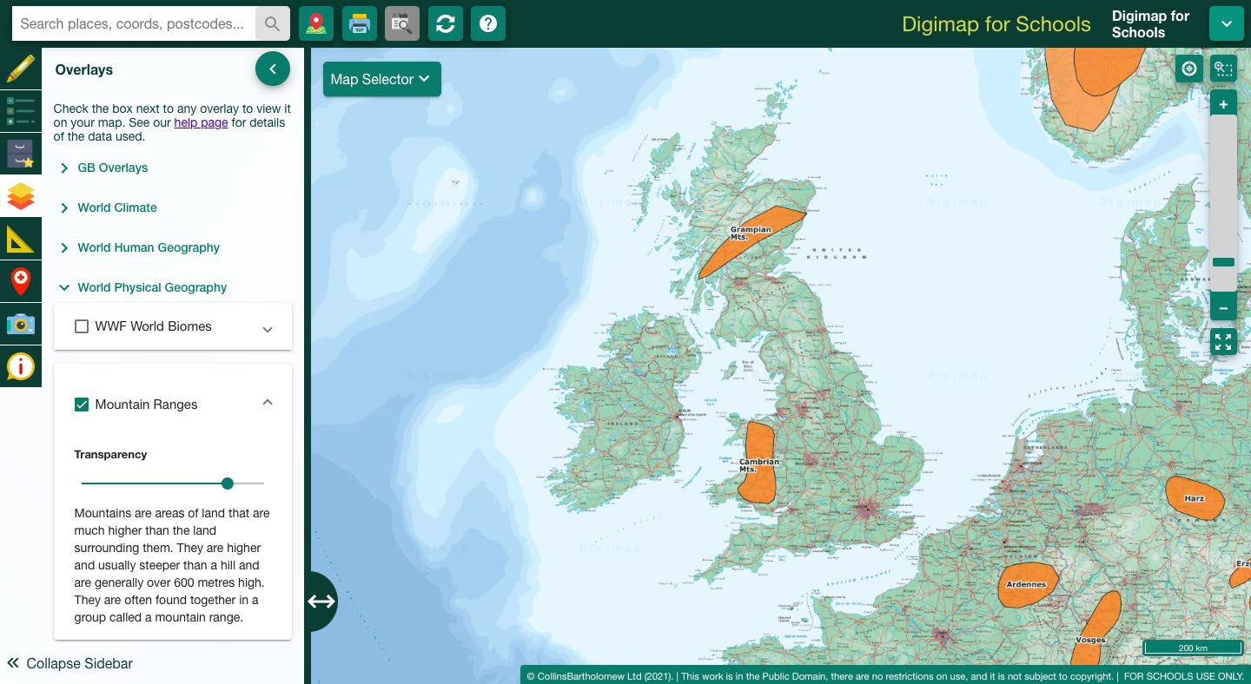

*Alt text: Map showing the mountain ranges in the UK- the Grampian and Cambrian mountains as orange shapes overlaid on the map.*

## BBC Bitesize quizzes

Extra activity for students that finish ahead of time.

Plate Tectonics: <https://www.bbc.co.uk/bitesize/guides/zyhv4wx/test>

Volcanoes: <https://www.bbc.co.uk/bitesize/guides/zvnbkqt/test>

## Bibliography

BBC Bitesize (2022a) Plate Tectonics. The crust. Available at: <https://www.bbc.co.uk/bitesize/guides/z2q6cwx/revision/3>

BBC Bitesize (2022b) Volcanoes. Case study: Iceland’s Eyjafjallajokull volcano. Available at: <https://www.bbc.co.uk/bitesize/guides/zvnbkqt/revision/4>

BBC Bitesize (2022c) Population density - Population and Migration. KS3 Geography. Available at: <https://www.bbc.co.uk/bitesize/guides/zkg82hv/revision/2>

BBC Bitesize (2022d) Site and Situation- Settlements in urban Areas. KS3 Geography. Available at: <https://www.bbc.co.uk/bitesize/guides/z2dmn39/revision/1>

BBC Bitesize (2022e) Plate Boundaries- Plate Tectonics. KS3 Geography. Available at: <https://www.bbc.co.uk/bitesize/guides/zyhv4wx/revision/2>

BBC Bitesize (2022f) Plate Tectonics Test Questions. KS3 Geography. Available at: <https://www.bbc.co.uk/bitesize/guides/zyhv4wx/test>

BBC Bitesize (2022g) Volcanoes Test Questions. KS3 Geography. Available at: <https://www.bbc.co.uk/bitesize/guides/zvnbkqt/test>

Global Volcanism Programme (2022). Volcanoes of the World Database. Smithsonian Institution. National Museum of Natural History. Available at: <https://volcano.si.edu/volcano.cfm?vn=372020>

Hjaltadóttir, S., Oddsson, B., et al (2010) Eruption in Eyjafjallajökull. Status Report: 18:00 GMT, 05 May 2010. Available at: [https://en.vedur.is/media/jar/Eyjafjallajokull_status_2010-05-](https://en.vedur.is/media/jar/Eyjafjallajokull_status_2010-05-05_IES_IMO.pdf) [05_IES_IMO.pdf](https://en.vedur.is/media/jar/Eyjafjallajokull_status_2010-05-05_IES_IMO.pdf)

Westerduin (2021a) Tectonic Plates User Guide. EDINA Available at: <https://digimapforschools.edina.ac.uk/files/overlay_guides/tectonic_plates_user_guide.pdf>

Westerduin (2021b) Volcanoes User Guide. EDINA Available at: <https://digimapforschools.edina.ac.uk/files/overlay_guides/volcanoes_user_guide.pdf>

3D Geography (2021) Settlement Patterns. Available at: <https://www.3dgeography.co.uk/settlement-patterns>

## Copyright

© EDINA at the University of Edinburgh 2022

This work is licensed under a Creative Commons Attribution-NonCommercial-ShareAlike Licence

